
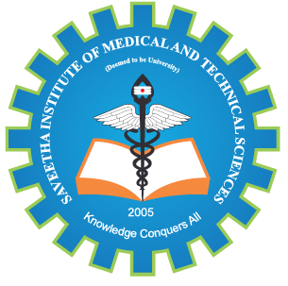
SIMATS ENGINEERING

Saveetha Institute of Medical and Technical Sciences
Chennai- 602105

Student Name: A. Reddy Prasad Reg. No.: 192472045
Course Code: CSA1706 Slot: B
Course Name: Artificial Intelligence
Course Faculty: Dr. Krishna Kumar Kathiresan
Project Title: AI-Driven Air Quality Monitoring and Prediction System
Module Photographs:
Architecture Diagram | Module1: Video Capture & Person Detection | Presentation Image
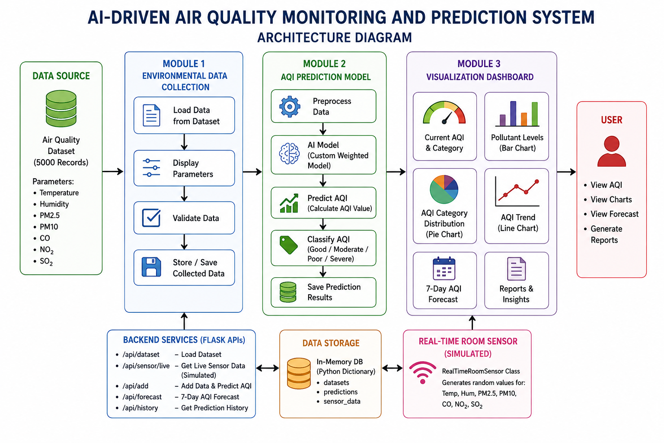 | 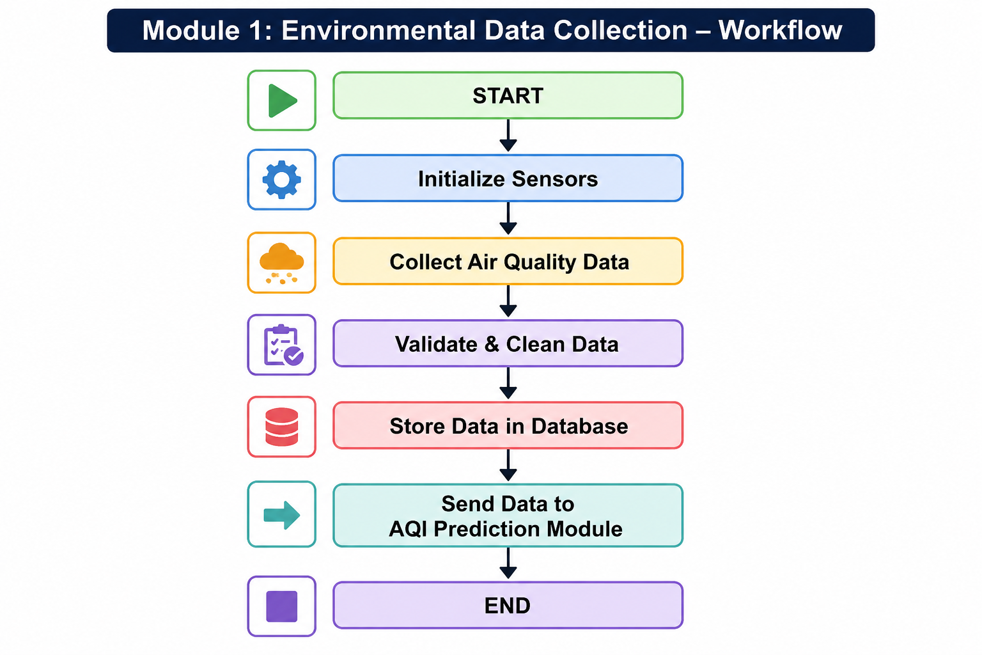 | 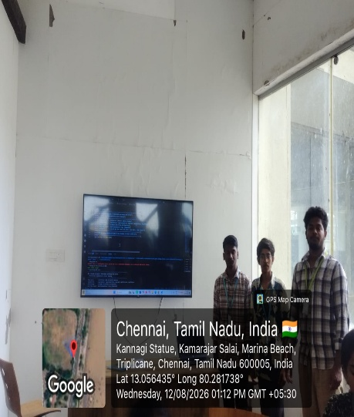
Project Description:
The AI-Driven Air Quality Monitoring and Prediction System is an intelligent environmental application designed to monitor and predict air pollution levels in real time. The system combines Artificial Intelligence, Machine Learning, and data analysis techniques to process air quality parameters and provide accurate pollution information.
The Air Quality Monitoring & Prediction Module is responsible for collecting and processing parameters such as PM2.5, PM10, CO, NO₂, SO₂, O₃, temperature, and humidity. Using Machine Learning algorithms, the system analyzes historical and real-time data to predict AQI levels and pollution trends. The predicted results are displayed to users, and alerts can be generated when pollution levels exceed safe limits.

Student Signature Guide Signature

